http://en.wikipedia.org/wiki/Chao_Phraya_River

Chao Phraya River

From Wikipedia, the free encyclopedia
Jump to: navigation, search
Chao Phraya River
Origin | Confluence of Ping River and Nan River
Mouth | Gulf of Thailand
Basin countries | Thailand
Length | 372 km (231 mi)
Source elevation | n/a
Avg. discharge | n/a
Basin area | 160,000 km² (141,398 mi²)
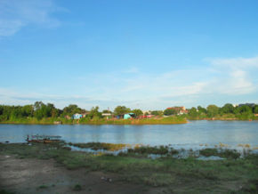
Origin of the Chao Phraya River in Nakhon Sawan
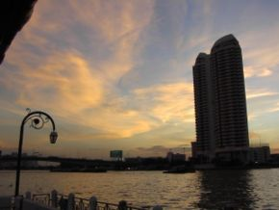
A view of the Chao Phraya River in Bangkok
The Chao Phraya (Thai: แม่น้ำเจ้าพระยา) is a major river in Thailand, with its low alluvial river plain marking the mainland of the country.
It begins at the confluence of the Ping and Nan river at Nakhon Sawan (also called Pak Nam Pho) in the Nakhon Sawan province. The Nan and its biggest confluent, the Yom River, flow nearly parallel from Phitsanulok till Chumsaeng in the north of Nakhon Sawan province. The biggest confluent of the Ping is the Wang River which enters near Sam Ngao district in Tak province. The Chao Phraya system drains an area of approximately 160,000 km², of which the largest contribution is the Ping with 35,000 km².
The Chao Phraya runs from north to south for 372 km from the central plains to Bangkok and the Gulf of Thailand. However in Chainat the river splits into the main river course and the Tha Chin river, which then flows parallel to the main river and exits to Gulf of Thailand the about 35 km west of Bangkok in Samut Sakhon. In the low alluvial plain which begins below the Chainat dam many small canals (khlong) split off from the main river, used for the irrigation of the rice paddies.
The cities along the river are Nakhon Sawan, Uthai Thani, Chainat, Singburi, Ang Thong, Ayutthaya, Pathum Thani, Nonthaburi, Bangkok and Samut Prakan relatively.
On old maps the river is named as Menam or Mae Nam, the Thai word for river. The name Chao Phraya is also a Thai feudal title, which can be translated as General. In the English-language media in Thailand the name is often translated as 'river of kings'.

